

openPlan Manual

# Introduction

openPlan (previously linkSlicerBlender) is an add-on for Blender and 3D Slicer. It integrates object data between these two powerful open-source applications to allow for real-time object synchronization and manipulation.

This add-on is provided as is, its intended use is to extend the functionality of Blender and 3D Slicer in medical planning and computer-aided design (CAD).

openPlan, Blender, and 3D Slicer have been researched for use in medical planning and guided surgery; however, the softwares (openPlan, Blender, 3D Slicer) do not possess FDA medical device clearance and hence are not intended for clinical use. User assumes all liability.

# System Requirements

* Operating System: Windows, MacOS, Debian Linux
* Blender 3.2
* 3D Slicer 5.0.3

# Features

* Linking single or multiple objects between Blender and 3D Slicer
  + Objects from Blender are automatically copied into 3D Slicer
  + Objects from 3D Slicer are automatically copied into Blender
  + Linked objects have their position, rotation, scale synchronized from Blender into 3D Slicer
  + Color and transparency are synchronized from Blender into 3D Slicer
* Unlinking single or multiple objects between Blender and 3D Slicer
* Deleting single or multiple objects between Blender and 3D Slicer
* 3D Slicer transverse, tangential, free-view curve visualization
* Project save and load

# Installation

1. Open Blender and navigate to Preferences
   * Upper left -> Edit -> Preferences
   * 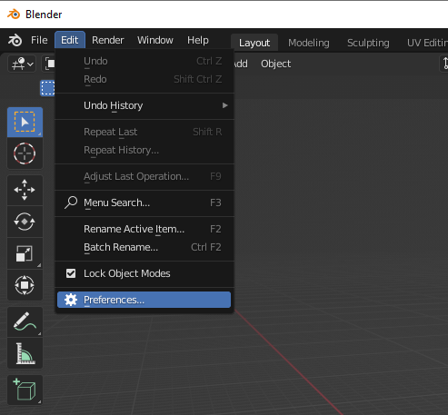
2. Click on Add-ons, then Install
   * 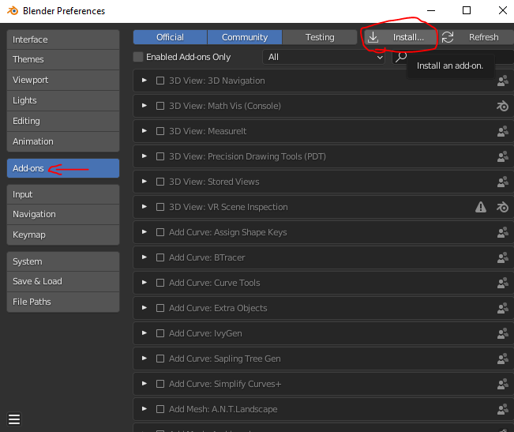
3. Navigate to where the openPlan zip file is located, select it, and click Install Add-on
   * 